Project Proposal

Jerry Webb

ITP 341 Android Programming

November 15, 2015

Green Drum Machine

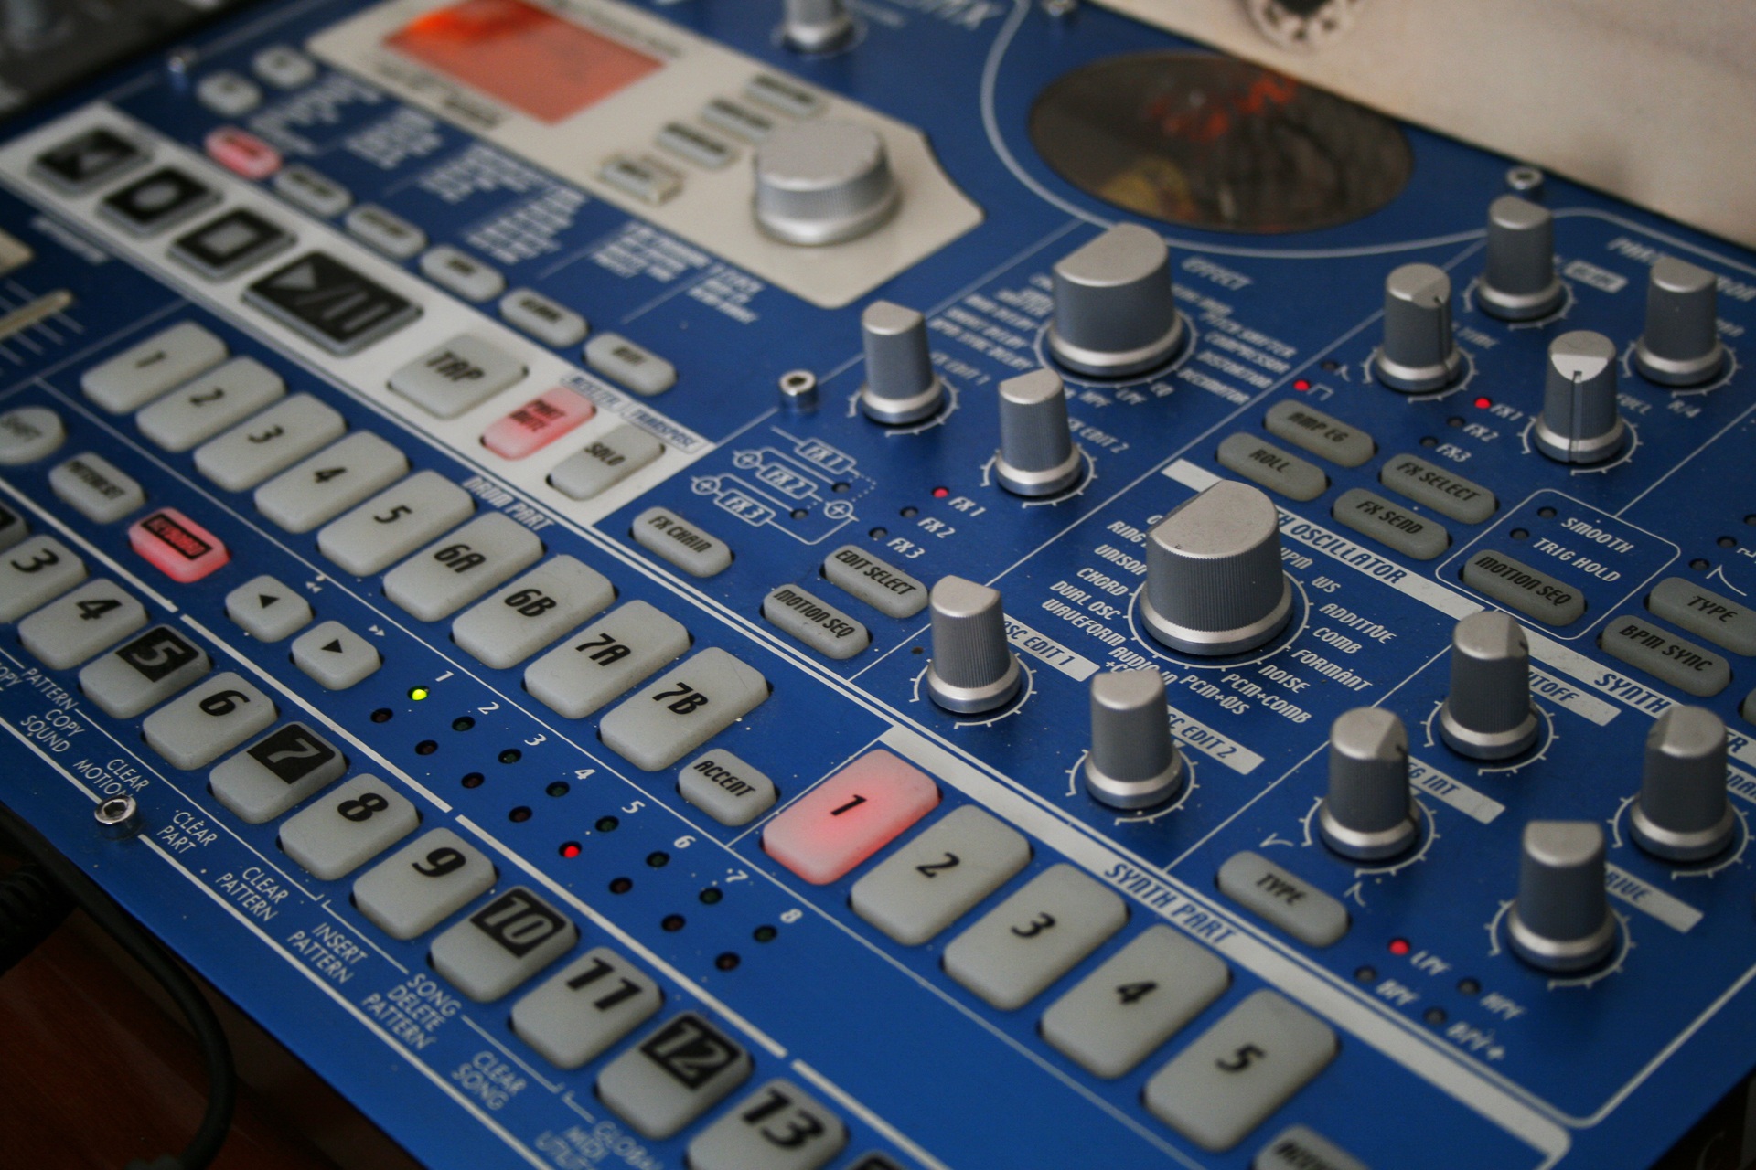

Green Drum Machine

This proposal is for the development of an Android OS app called 'Green Drum Machine'.

**App Definition Statement**

'Green Drum Machine' (GDM) is an Android app that allows the user to create a drum sequence anywhere by emulating physical beat machine hardware. The user can create and edit full length beats by using the midi sequencer.'

**Key Features**

* Allow users to create and edit beats on their phone or tablet, without the requirement of any extra physical hardware.
* Record and edit drum beat sequences using the sequence editor
* For maximum real estate, smaller devices such as phones will automatically orient to landscape mode
* Edit the volume of each of the 8 tracks using the Mixer
  + Mixer tracks consists of a volume fader, mute and solo button
  + Solo will mute all of the other tracks except for the selected track
  + Each track is then bussed into the master track, which controls the total volume
  + The VU meter for each track will display that track's volume independent of the other sounds
* Users can load sounds from external storage to each of the pad to add for a diverse set of sounds
  + Small sound bank on the side for quick access to different sound files
  + Shows information such as the name of the sound, the duration, and (if possible) the wave form
* Users can save and load beats and corresponding information
  + Name of the file
  + Saves midi sequence, sounds assigned to pads, fader levels of each track, etc.

**Technology Items**

* Android MIDI APIs. Reference: <http://developer.android.com/reference/android/media/midi/package-summary.html>
* Media Player APIs. Reference: http://developer.android.com/reference/android/media/MediaPlayer.html
* STM32 Nucleo FPGA Board

**Images with items that leave the screen will be scrollable in final product

